Understanding the Language of Advertising.

Grade 7 Unit
What is this unit about? .We shall be learning about the purpose of advertising. We will be able to identify the type of language used in advertising.
Using our knowledge we shall create our own advert.

Advertisements are a special type of persuasive language.
Their purpose is to sell a product or a service. They do this by aiming at a particular type of customer. They use carefully chosen, positive language. This makes them appeal to some aspect of the audience’s personality.
They try to make the audience believe that their product will make them;
- Slimmer
- Happier
- More comfortable
- Healthier
- Successful
- More fashionable
- More beautiful
- More intelligent
- In fact make them the envy of all their friends!
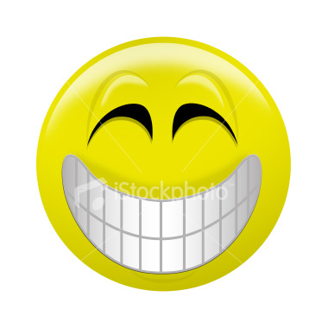

They use carefully chosen language to appeal to their target audience, such as:
Special Offer!
Free!
Look no further
Cheaper
Exclusive
Bargain
They promise:
- To cure all your ailments
- To solve all your problems
- To change your life for the better
They make you feel that you cannot live without their product.
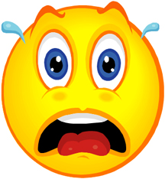
“I’ve got to have it!!!!!!!”

Let’s look at some commercials....
Think of your favorite commercial and explain what it is and why you like it. Why do you remember it?

Ads are memorable because they are filled with persuasive language. The general features of persuasive language are;
- Use of flattery
- Use of figurative language
- Repetition, repetition, repetition
- Use of rhetorical questions
- Hyperbole/exaggeration
- Decorating the facts
- Emotive language
- It ‘hooks’ the reader
- It appeals to your senses
- Makes you ‘gotta have it’
- Uses celebrities/competitions to promote
- Contains humor
- Has a memorable slogan/image

However, ads don’t always need words to sell their product. Try to identify these famous visual ads.

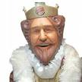

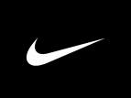

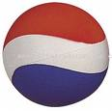

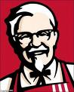

---------------
What are advertising slogans?
Advertising slogans are short, often memorable phrases used in advertising campaigns. They are claimed to be the most effective means of drawing attention to one or more aspects of a product.
Advertising slogans often play a large part in the interplay between rival companies. An effective slogan usually:
- states the main benefits of the product or brand for the potential user or buyer
- implies a distinction between it and other firms' products - of course, within the usual legal constraints
- makes a simple, direct, concise, crisp, and apt statement
- is often witty
- adopts a distinct "personality" of its own
- gives a credible impression of a brand or product
- makes the consumer feel "good"
- makes the consumer feel a desire or need
- is hard to forget - it adheres to one's memory (whether one likes it or not), especially if it is accompanied by mnemonic devices, such as jingles, pictures or film sequences on televised commercials
- sounds good
Write down as many slogans you can remember from popular adverts. Why do you think you remember these slogans?

Can you identify these popular slogans?

"Just do it!"

"I'm lovin' it!"

"The milk chocolate that melts in your mouth - not in your hand."

What are rhetorical questions?

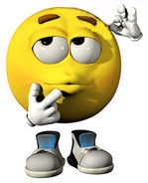

A rhetorical question is a figure of speech in the form of a question posed for its persuasive effect without the expectation of a reply.
Rhetorical questions encourage the listener to reflect on what the implied answer to the question must be. When a speaker states, "How much longer must our people endure this injustice?" or "How many times do I have to tell you to stop walking into the house with mud on your shoes?" - No formal answer is expected. Rather, it is a device used by the speaker to state something or deny something.

Imperative Language in Advertising

What does imperative mean?
Imperative means a command or an order, e.g. the Nike ad;
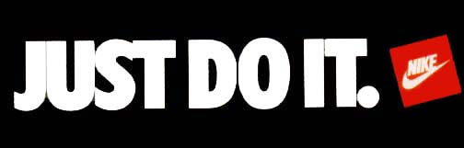
Other examples of imperative advertising might say;
- Try it today
- Go on – change the way you look
- Book online NOW!
- C’mon
- Get up, have some.
Why do ads use imperative language?
- To motivate
- To guide/lead the audience
- To be noticed
- To persuade the audience to use their product
Jargon
- What is Jargon?
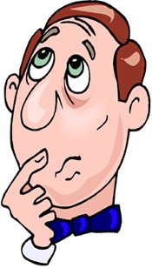

- Jargon is a term that is used to describe a set of words that have a specific meaning in a specific context.
So for example legal jargon would include words such as plaintiff, defendant, mens rea, implied repeal.
Whereas another branch of jargon, say IT jargon, has words such as processor, HTML, bit-rate, virus.

