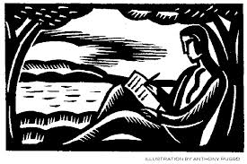
COMPARE / CONTRAST -
TWO PARAGRAPHS

You are going to write two (2) paragraphs comparing and contrasting “The Charge of the Light Brigade,” and “For My Father.”

Your completed Venn diagram will act as the pre-write for this assignment.

You are to incorporate what we have previously learned about creating a well-constructed paragraph.

Use the checklist below to address the following requirements:

- A well developed topic sentence:
  - main idea clearly stated
  - attention getting
  - tells what the paragraph is about

- 3 examples and support per paragraph
  - 3 for comparison / 3 for contrast

- Proper punctuation at the end of your sentences (. ? or !)

- A conclusion:
  - Restated the main idea
  - Sums up what you said
  - May include a call for action or an opinion

- Do not repeat and overuse the same words.
  - Try to incorporate vocabulary words that are new, different and sophisticated.

For this assignment you are to use transition words.***

- *** You are to incorporate at least 2 transition words per paragraph to connect ideas from sentence to sentence and / or paragraph to paragraph.
  - Choose from the word lists below.
  - Underline your 4 transition words.

- The first paragraph is a comparison
    - how the two poems are alike.

Transition words that show comparison (similarities) :
* in addition * same as
* similarly * compared to
* likewise * as well as
* corresponding * at the same time
* just as

- The second paragraph is a contrast
      - how the two poems differ.

Transition words that show contrast (differences):
* however * conversely
* even though * on the other hand
* unlike * although
* on the contrary * meanwhile
* in contrast

You will have some class time to work on this.

The typed, clean revision and Venn diagram will be

due_________________________.

