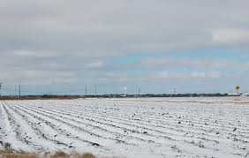
Dreams
Name:_____________________________________ period:_________________
by Langston Hughes

Hold fast to dreams
For if dreams die
Life is a broken-winged bird
That cannot fly.

Hold fast to dreams
For when dreams go
Life is a barren field
Frozen with snow.

What is the theme of the poem “Dreams”? Show evidence for support.

Identify a metaphor in the poem. How does it connect to the meaning of the poem?

Identify the rhyming words and describe how they are effective in the poem.

What is the tone of the poem?

Complete the Venn diagram below. Compare the two poems “Dreams” and “Dream Deferred.” How are they alike? (2 points) How are they different? (2 points each)

