Name:
Period:

Reader’s Choice:
Independent Reading Book Report
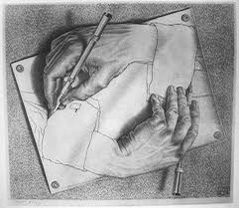

Directions:
You are to complete all 3 parts of this assignment.
Parts 1 & 2 are to be typed, following the format outlined below.

Due date: Friday, October 14th

Part 1:
- Book Title:
- Author:
- Summary of the book (at least 10 complete sentences).
- Protagonist:
- Why?
- Antagonist:
- Why?

Part 2:
You are to pretend you are a book critic and give your opinion of the book you just read. You should include parts of the book that you thought 'good'; and parts that you thought were not so “good.”* You have two jobs. First you are to convince the public that this book is either worth reading or one to avoid. Your second job is to convince me that you have in fact read this book! ·
Be sure to be specific and include details to support your argument. Remember you are the critic. Your word can make a book a success or a failure, so be convincing!
*You are to avoid using the word 'good' in your critique.

Part 3:
Fill out the attached plot curve sheet as it pertains to your chosen book.
Be sure to be specific and include details and examples from the book.

Plot Curve

Book Title & author:

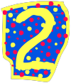

Climax

Rising Action
Denouement
Falling Action
Exposition

