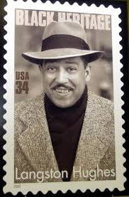
The Life of Langston Hughes
(February 1, 1902 – May 22, 1967)

James Mercer "Langston" Hughes was born in Joplin, Missouri. His father abandoned the family. Young Langston was left to be raised by his grandmother in Lawrence, Kansas. After her death, he went to live with family friends. Due to an unstable early life, his childhood was not a happy one but it heavily influenced the poet he would become. Later, he lived again with his mother--who had remarried--in Lincoln, Illinois, and eventually in Cleveland, Ohio. During high school he wrote for the school newspaper, edited the yearbook and began to write short stories, poetry, and dramatic plays. Hughes was influenced by American poets Paul Laurence Dunbar, Carl Sandburg and Walt Whitman. He also briefly lived in Mexico with his father, who did not support his son's desire to be a writer. Langston studied engineering at Columbia University for a year (1921-22), eventually leaving as he had a growing desire to return to Harlem and write poetry.

Hughes worked various odd jobs, including a brief tenure as a crewman aboard the SS Malone in 1923, spending six months traveling to West Africa and Europe. He moved to Washington D.C. While working as a busboy at a restaurant, Hughes tucked a few of his poems under the dinner plate of then-reigning poet Vachel Lindsay. Lindsay shared the poems during his reading that night, and in the morning Hughes was crowned Lindsay's new discovery, the "busboy poet." The following year Hughes enrolled at historically black Lincoln University, where he befriended classmate Thurgood Marshall. Hughes received a B.A. in 1929 and a Litt.D. in 1943. Harlem was Hughes' primary home for the rest of his life.

Hughes achieved fame as a literary luminary during the Harlem Renaissance of the 1920s. In 1930 his first novel, "Not Without Laughter", won the Harmon gold medal for literature. Hughes was particularly known for his insightful, colorful portrayals of black life in America from the 1920s through the 1960s. His work was also known for his engagement with the world of jazz and the influence it had on his writing, as in "Montage of a Dream Deferred." His life and work were enormously important in shaping the artistic contributions of the Harlem Renaissance.

Unlike other notable black poets of the period, Hughes refused to differentiate between his personal experiences and the common experience of black America. He told stories of people in ways that reflected their actual culture, including their suffering and their love of music, laughter and language itself.

In addition to leaving us a large body of poetic work, Hughes wrote 11 plays and countless works of prose, He edited numerous poetry anthologies, wrote an acclaimed autobiography ("The Big Sea"), and co-wrote the play "Mule Bone" with Zora Neale Hurston.

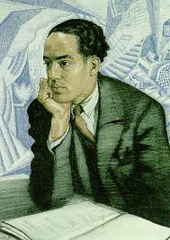
In 1967 Hughes died from complications following abdominal surgery, related to prostate cancer, at the age of 65. His ashes are interred beneath the foyer floor of the Arthur Schomburg Center for Research in Black Culture in Harlem. The design on the floor medallion reads, "My soul has grown deep like the rivers."

Scholastic News

